# Conclusion

## 1 - Set Theory

### Set

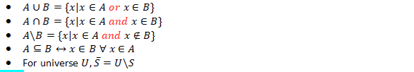

*complement of S -> U\S

### Double Containment Proof

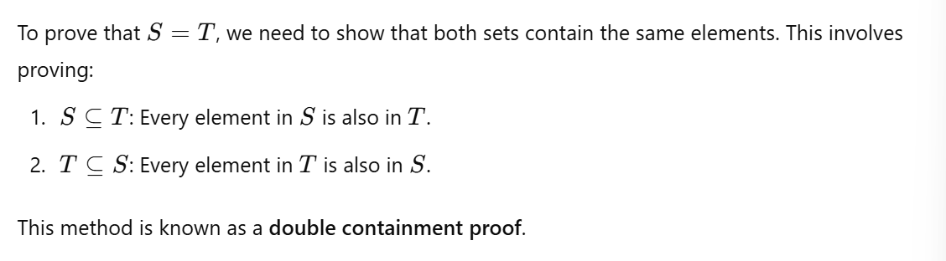

## 2 - Sets, Functions and Sequences

### Cartesian Product of Sets

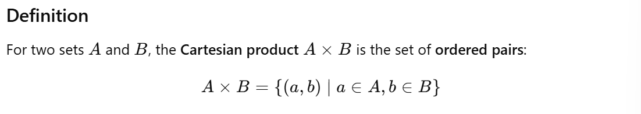

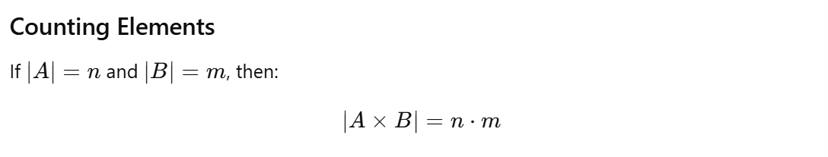

### Function Terminology

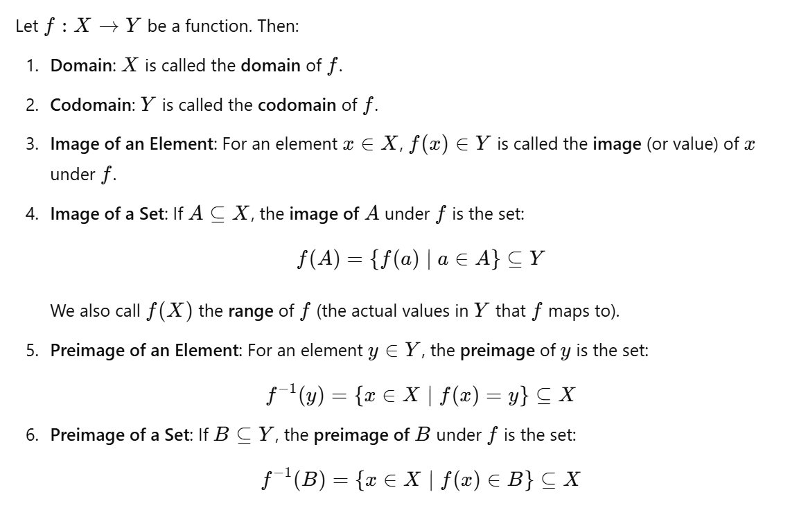

### Types of Functions

1. Surjective (Onto) Functions

* 

1. Injective (One-to-One) Functions

* 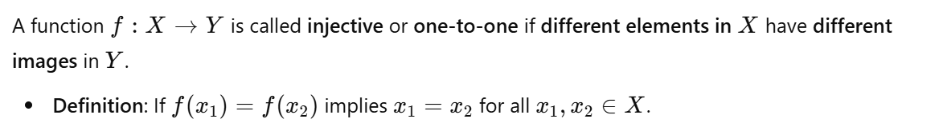

1. Bijective (One-to-One Correspondence) Function

* 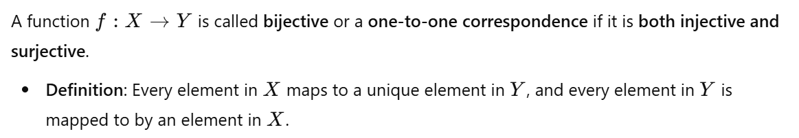

### Proving or Disproving Properties of f: X→Y

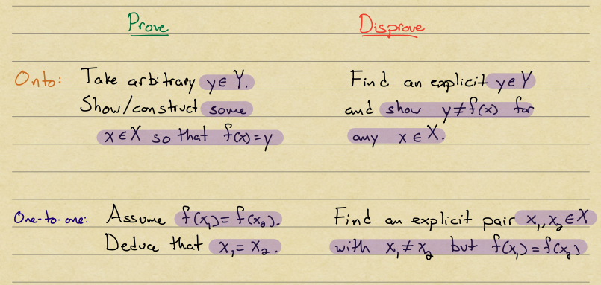

### Functions and Finite Sets

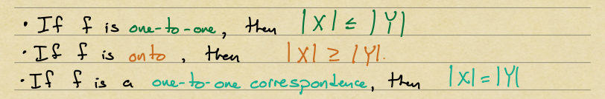

## 3 - Divisibility, Prime numbers, Euclidean Algorithm

### Divisibility Definition

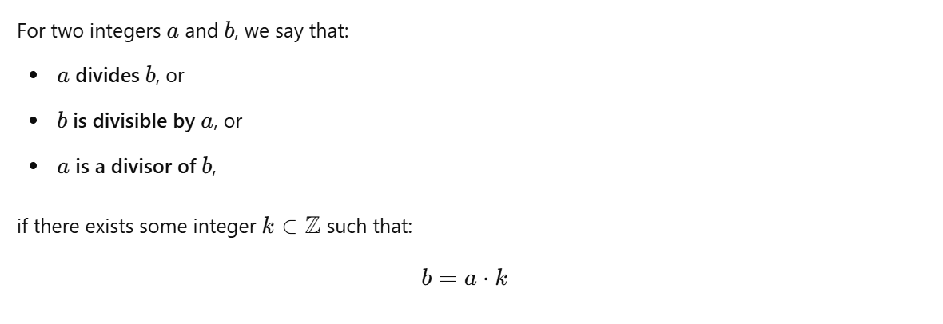

### Quotient Remainder Theorem

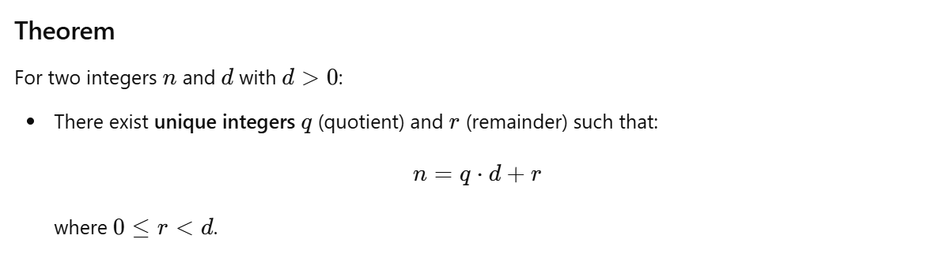

### Modular Arithmetic

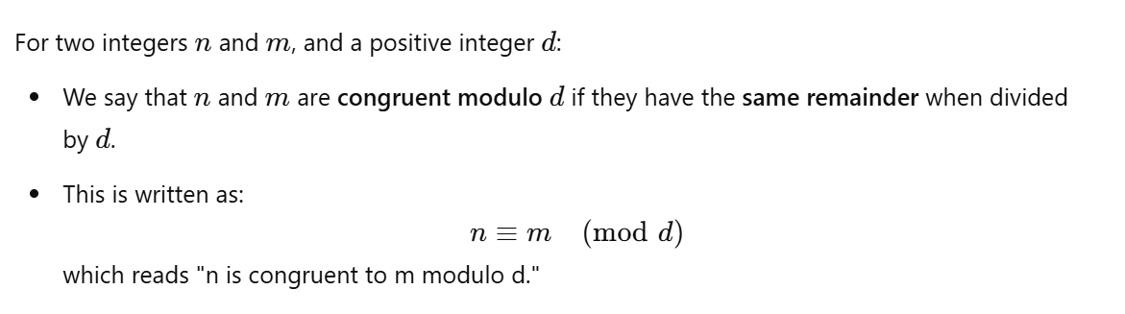

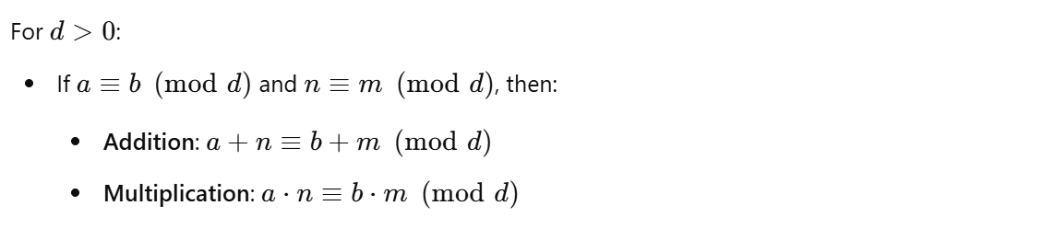

### Fundamental Theorem of Arithmetic (FTA)

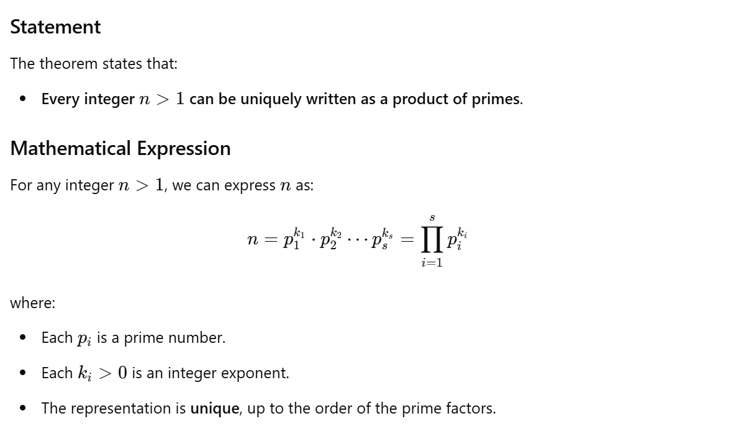

### Greatest Common Divisor (GCD)

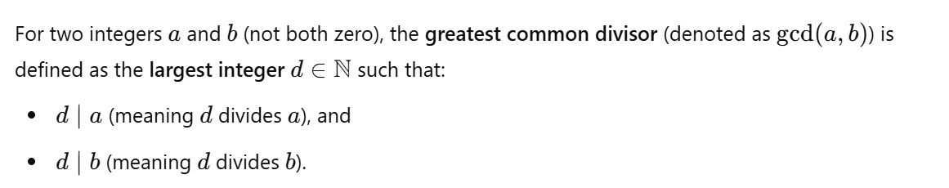

### Least Common Multiple (LCM)

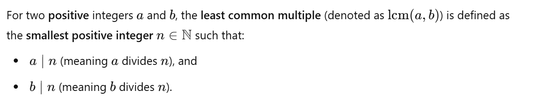

### Euclidean Algorithm

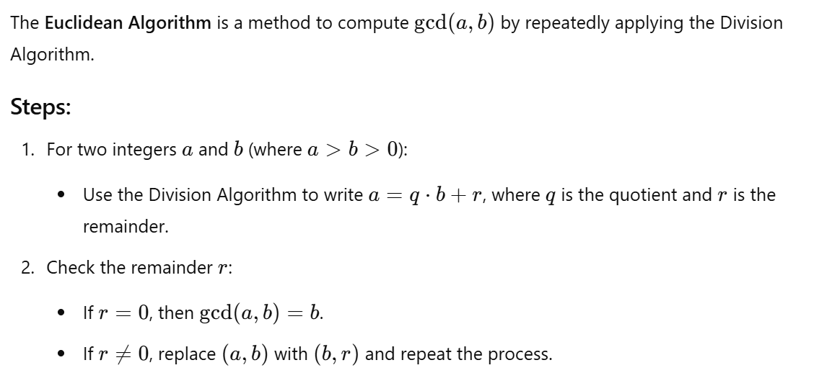

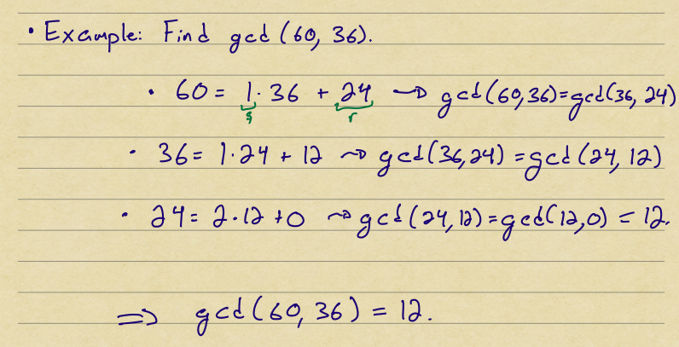

### Base b Expansions

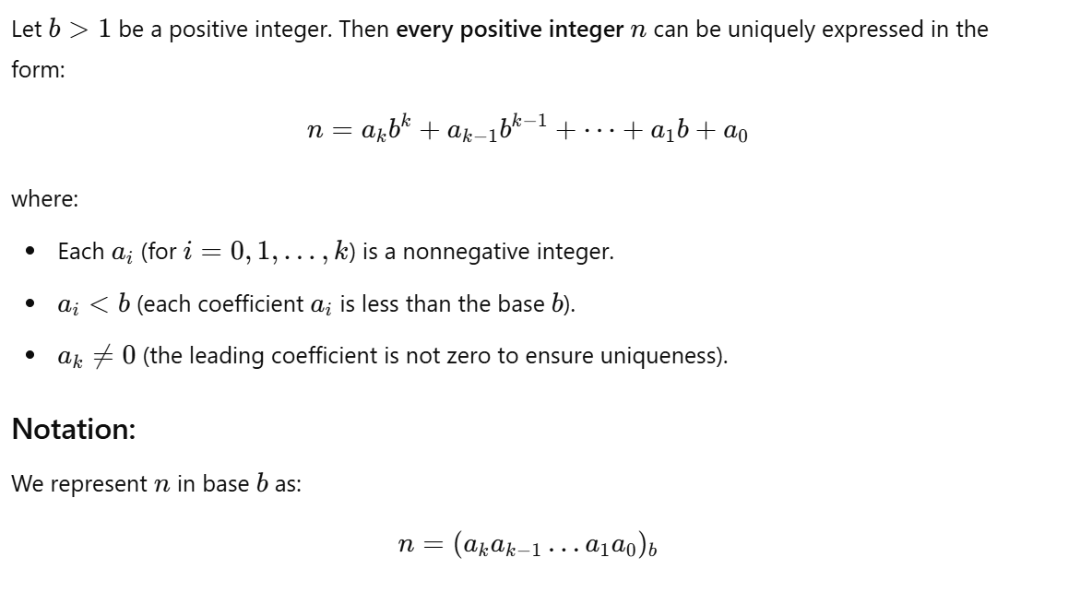

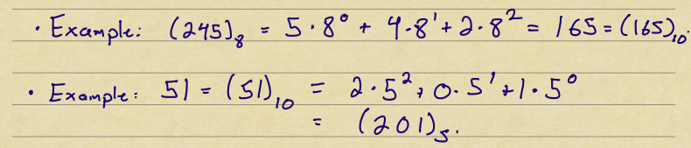

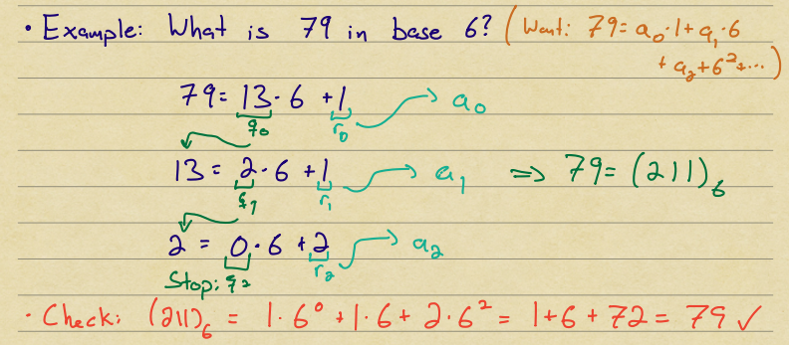

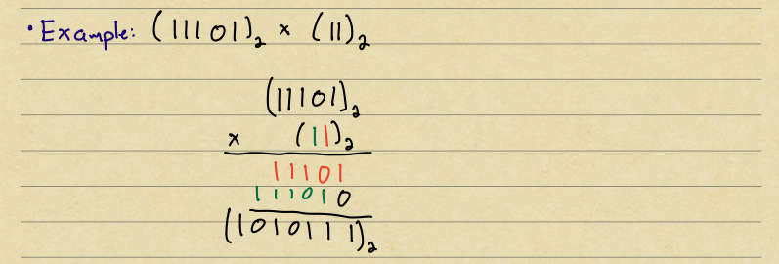

## 4 - Counting, choosing k items from n

### Summary

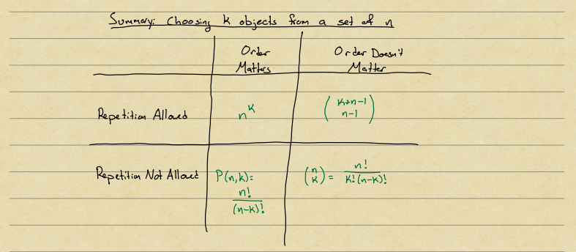

## 5 - Binomial Theorem, Inclusion-Exclusion and Catalan numbers

### Inclusion-Exclusion principle



### Pigeonhole Principle

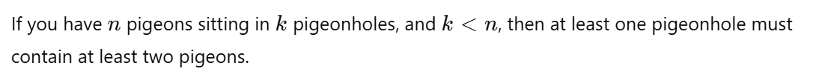

#### Proof

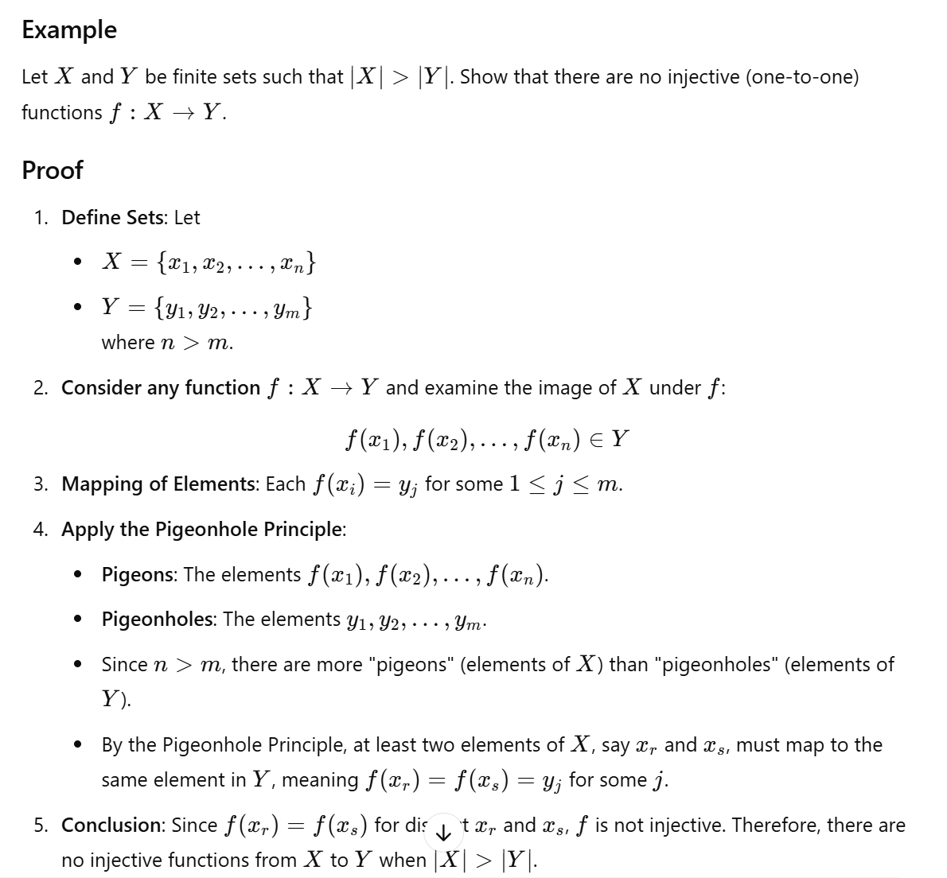

### The Binomial Theorem

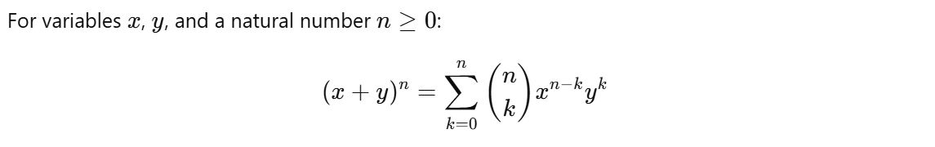

### Pascal's Identity

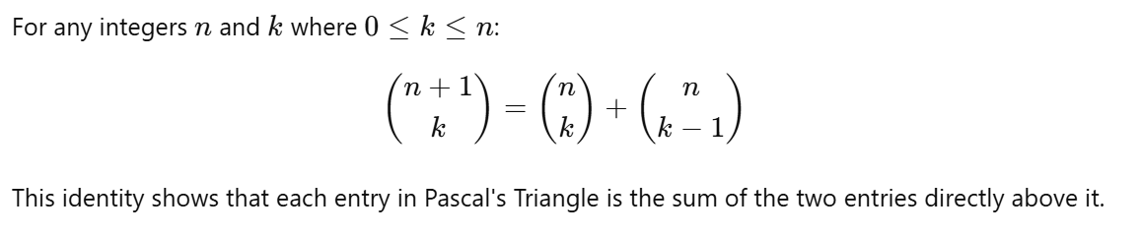

### Catalan Numbers

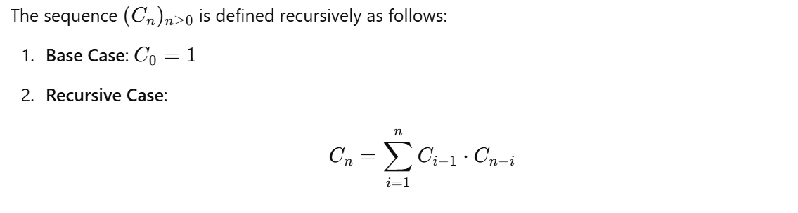



#### Proof

## 6: Probability

### Distributions of Random Variables

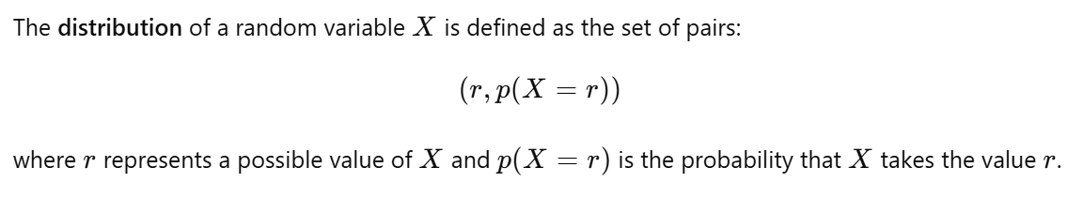

### Conditional Probability



### Independent Events

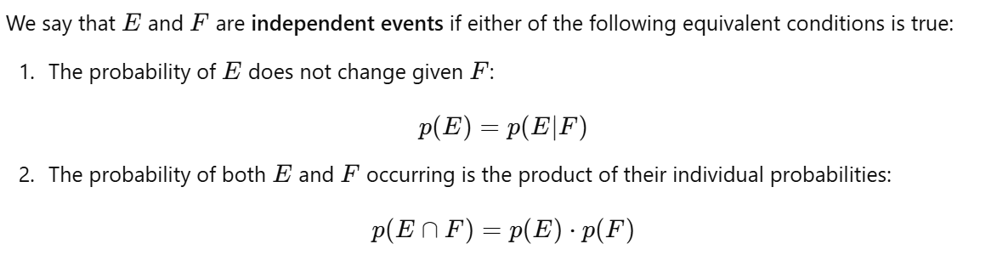

### Complementary Events

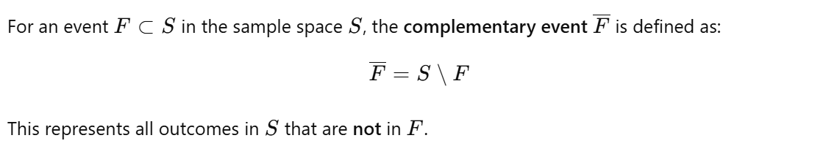

### Bayes' Theorem (in cheatsheet)



### Expected Value



### Variance







### Standard Deviation

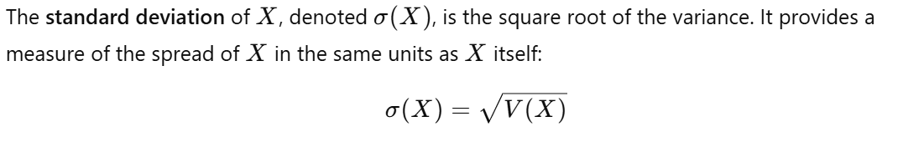

### Properties for Independent Random Variables

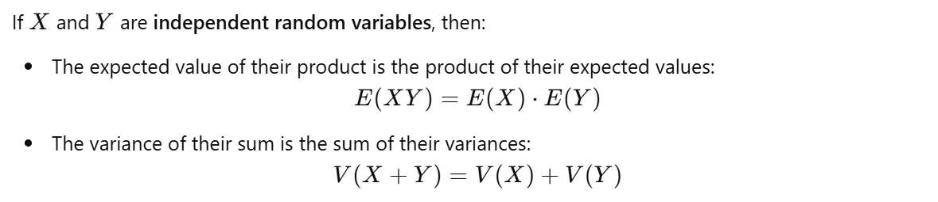

## 7 - Basics on Graph Theory

### Simple Graph

A **simple graph** is a graph that has no loops (edges connecting a vertex to itself) and no parallel edges (multiple edges connecting the same pair of vertices).

### Degrees of Vertices

#### Incidence



#### Adjacency



### Handshake Theorem

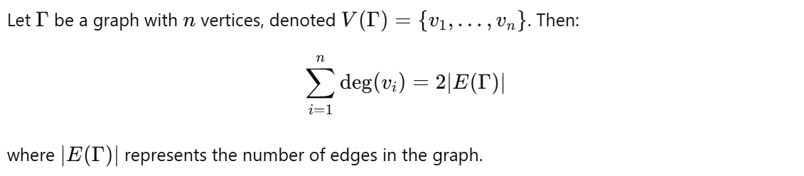

#### Corollary

For any graph Γ, there must be an **even number of vertices with odd degree**.

### Directed Graphs



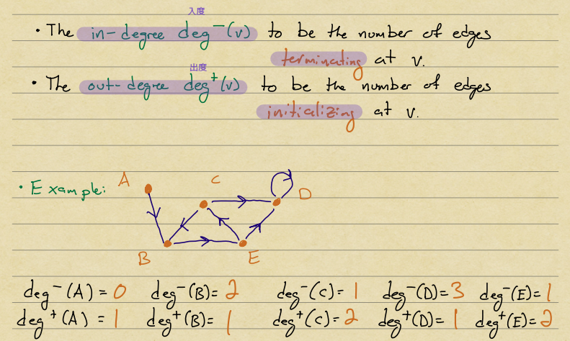

### Handshake Theorem for Directed Graphs



### Complete graphs

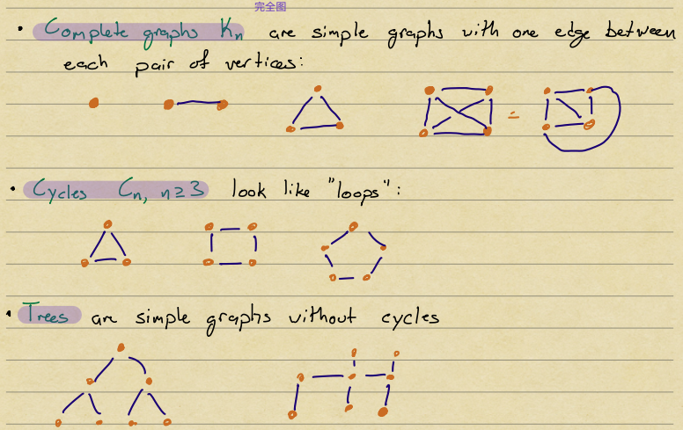

### Euler Circuit

A **path** of nonzero length (having at least one edge) is called:

1. **Simple**: if it does not repeat any edge. 每条边恰好一次
2. **Circuit**: if it begins and ends at the same vertex. 闭合路径
3. **Euler Circuit**: if it is a simple circuit that contains every edge of the graph.

Let Γ be a **connected** graph. Then Γ has an **Euler circuit** if and only if every vertex has an even degree.

### Isomorphic Graphs

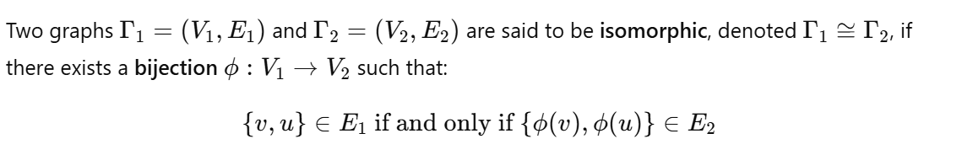

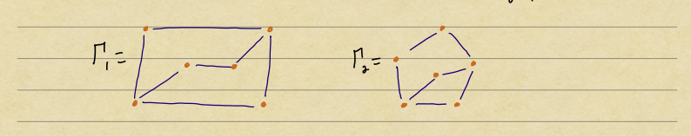

### Graph Invariants

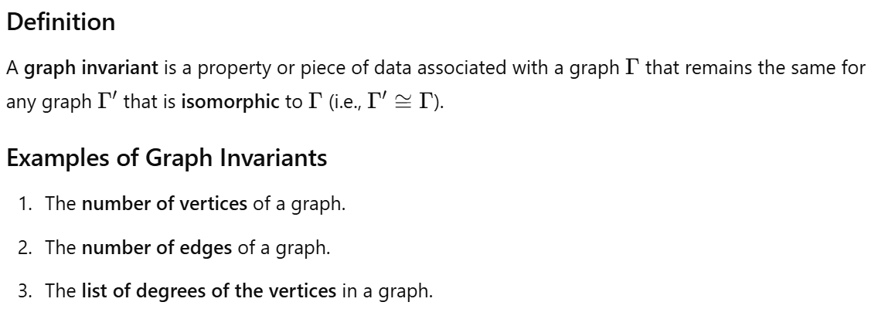

### Adjacency Matrices

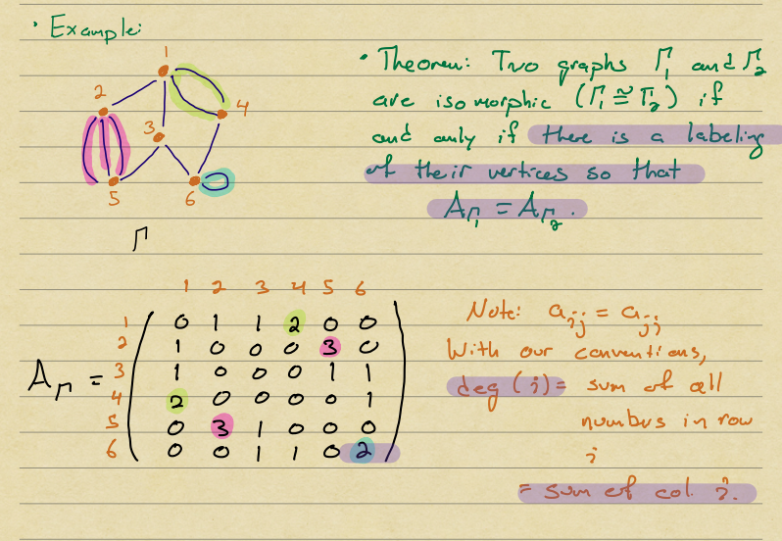

### Path on Graphs

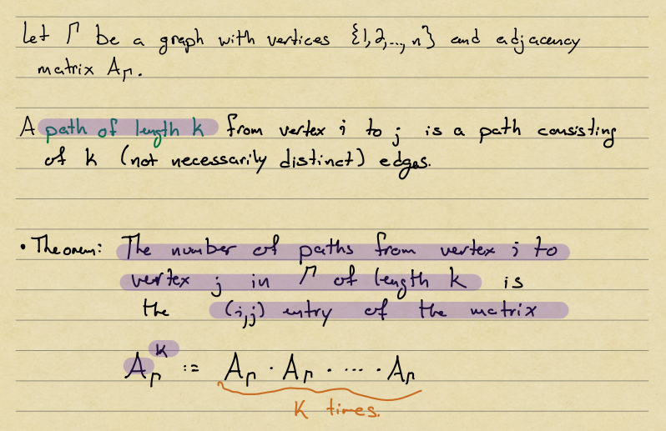

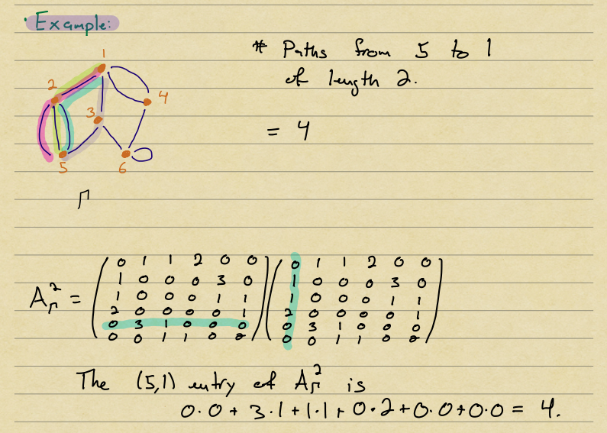

## 8 - Equivalence Relations, Closures

### Relation

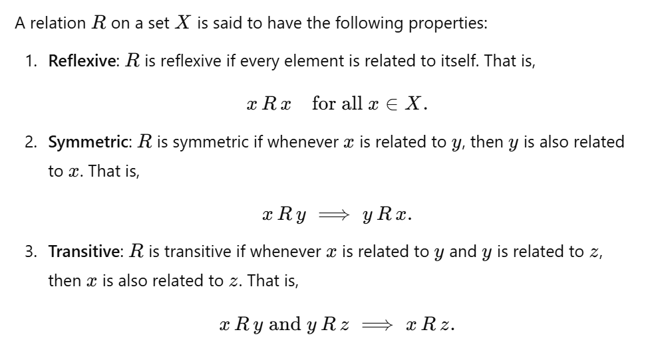

### Equivalence Class

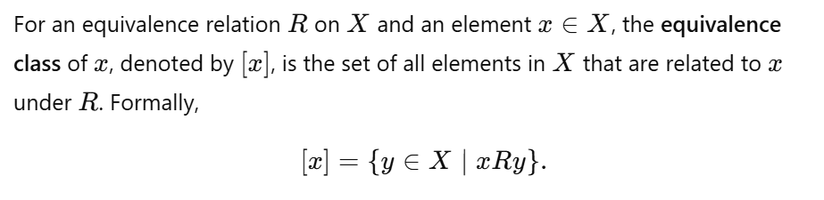

### Complementary Relation (not important)

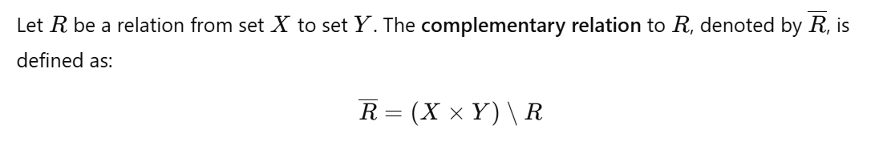

### Composition of Relations (not important)

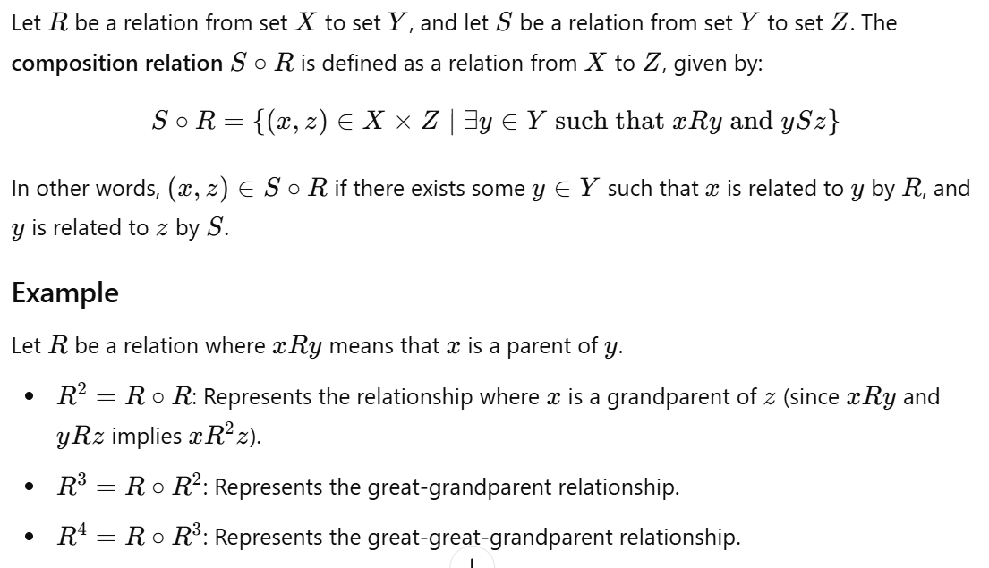

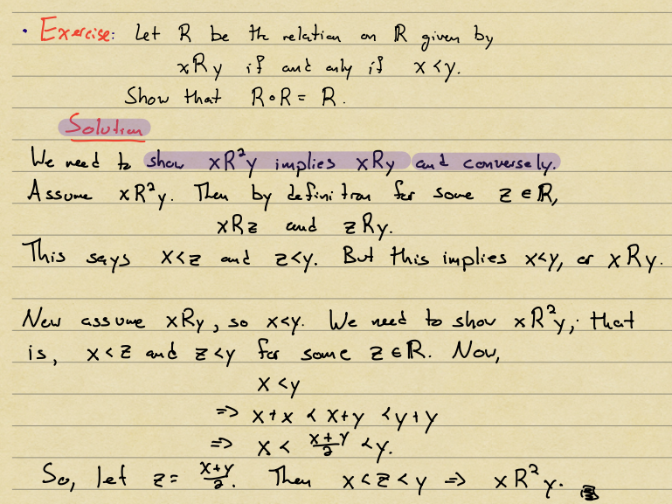

### Partitions of Sets

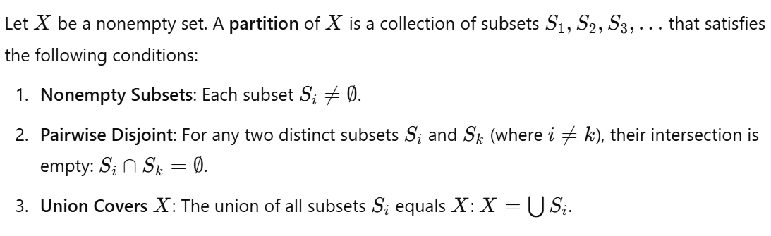

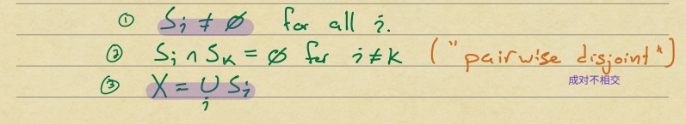

*Z = S1 U S2 U S3

### Equivalence Classes and Partitions

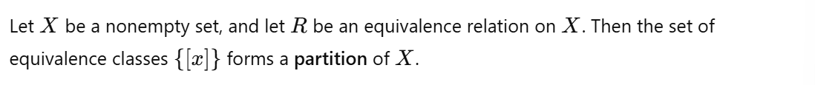

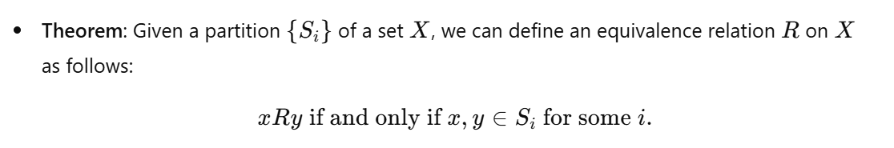

### Anti-Symmetric

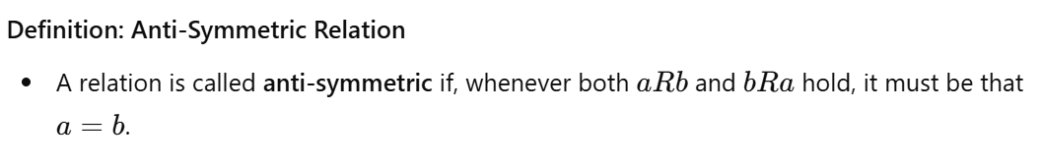

### Partial Order

* Reflexive
* Anti-symmetric
* Transitive

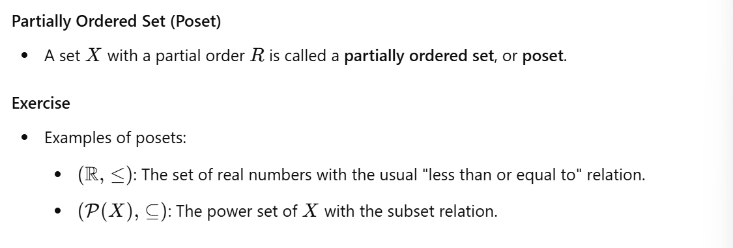

### Total Order

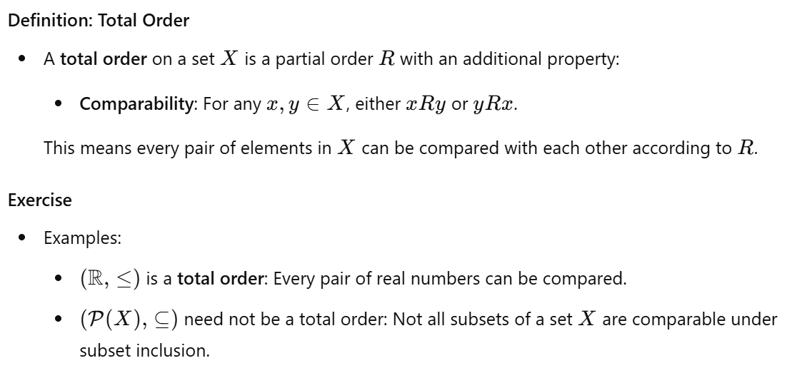

### Reflexive Closure

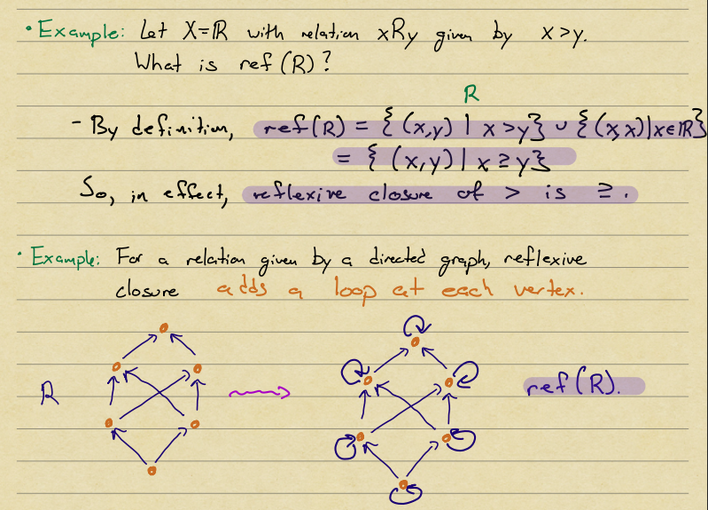

### Symmetric Closure

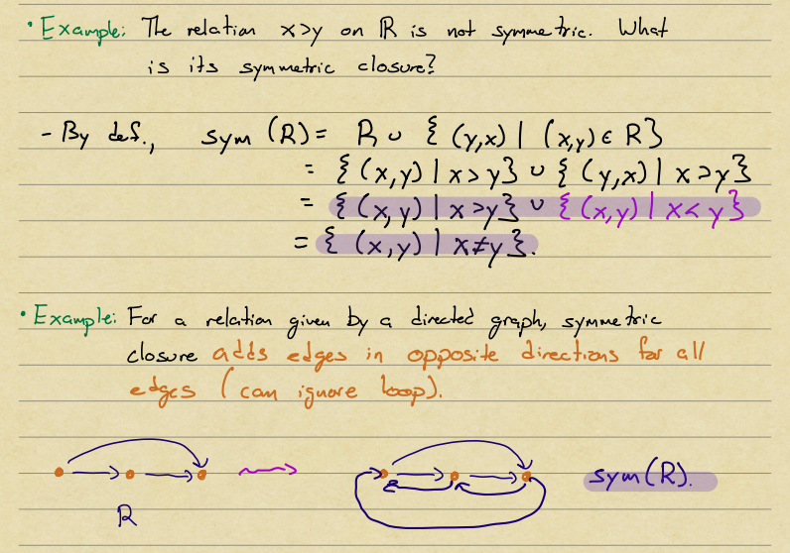

### Transitive Closure

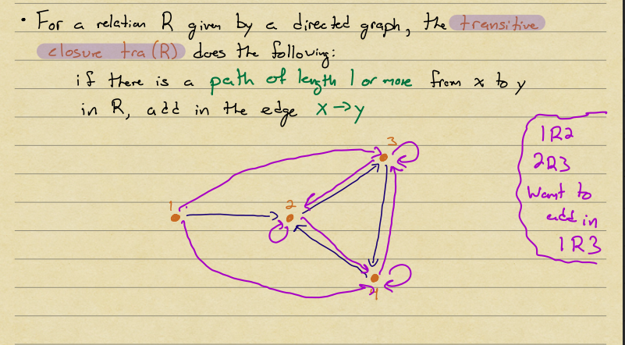

### Connectivity Relation

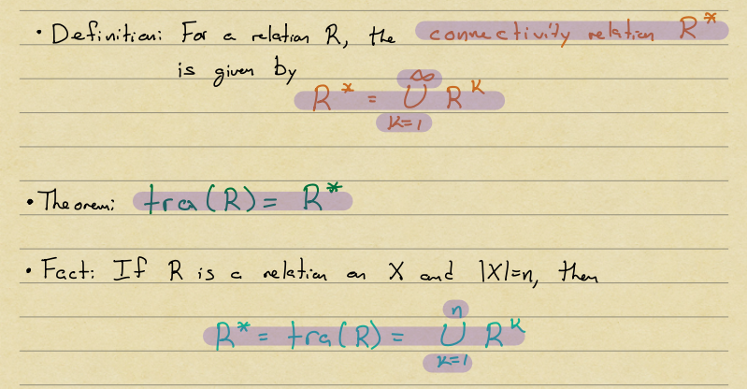

## 9 - Propositional Logic

### Negation, Conjunction, Disjunction

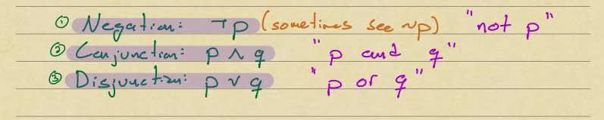

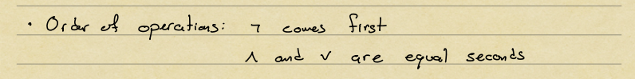

### Contradictions and Tautologies

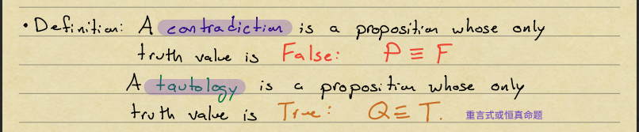

### Conditionals

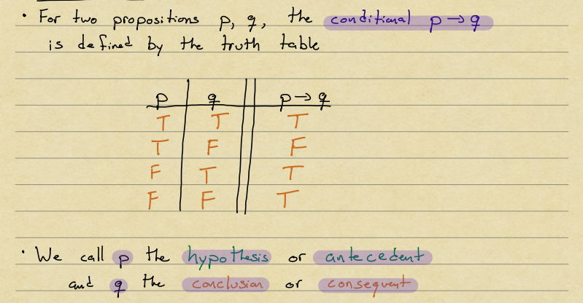

### Constructions on Conditionals

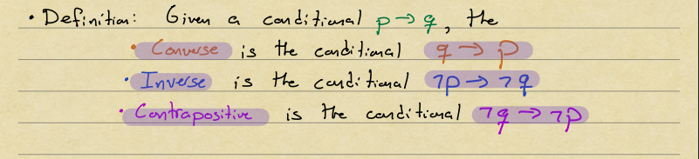

### Biconditional

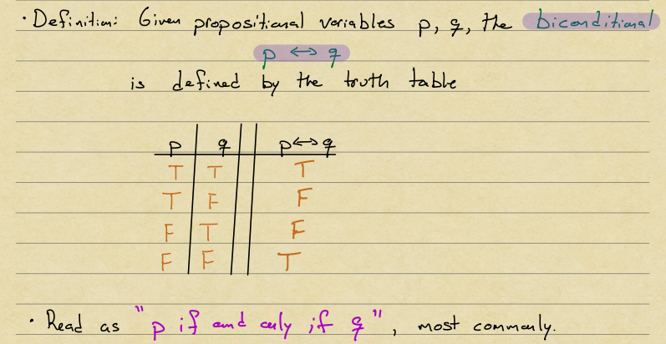

### Satisfiability

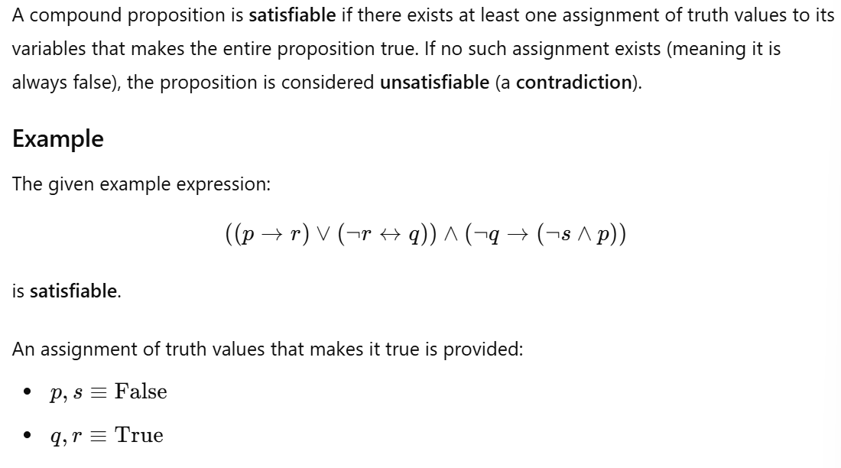

### Predicates

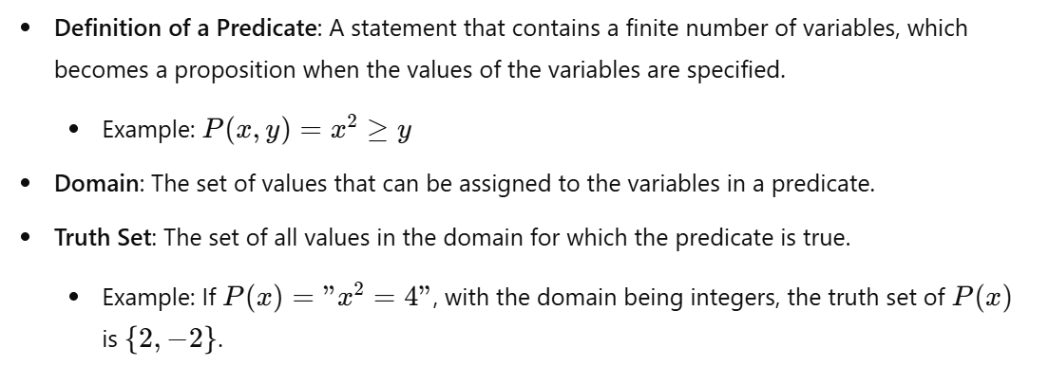

### Universal quantifier

### Existential quantifier

### Negating Multiple Quantifiers

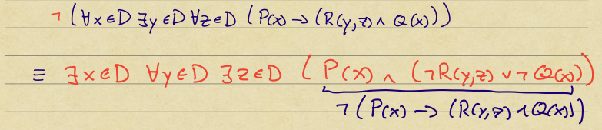

### Valid and Invalid Arguments

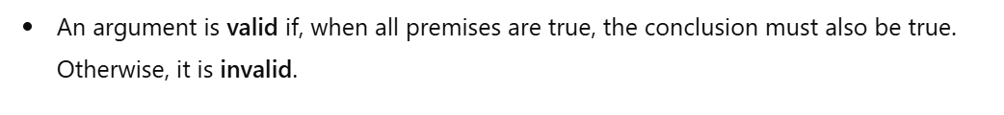

## 10 - Quantifiers, Predicates, and Proofs

### Basic Logical Inferences

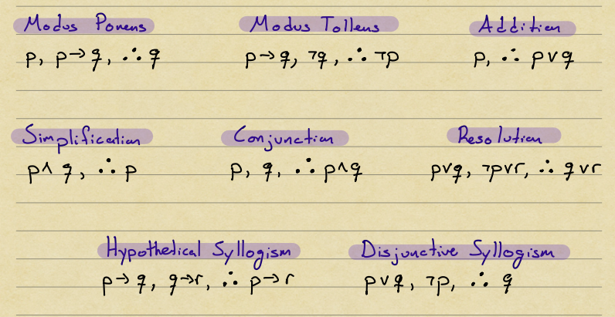

*Premise

### Logical Inferences for Quantifiers

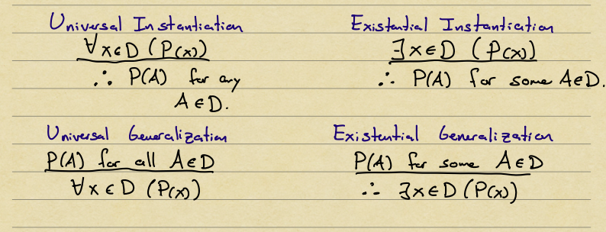

### Direct Proof

### Proof by Contrapositive

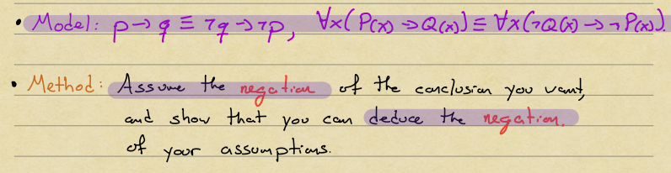

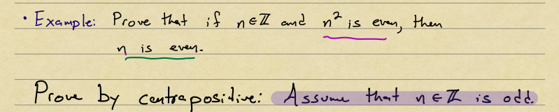

### Proof by Contradiction

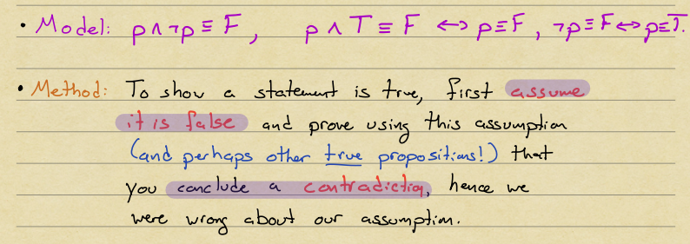

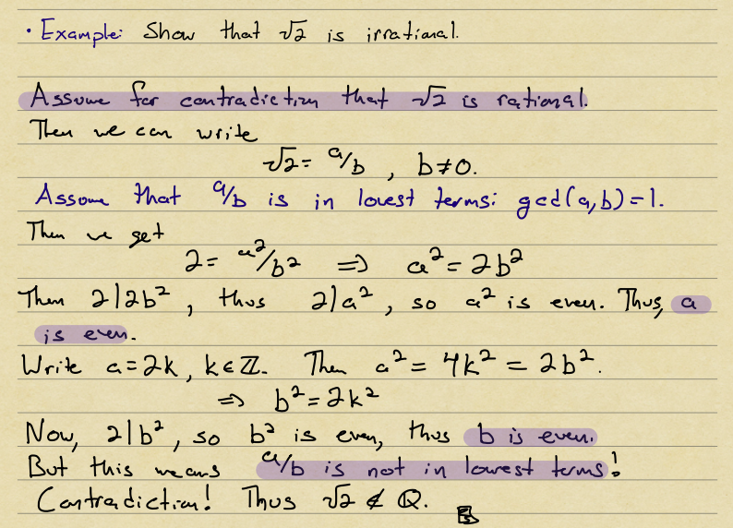

## 11 - Induction, Recursion, and O-notation

### Induction Example

Base case: for ...

Inductive step: Assume ... Then...

Conclude: Thus..., by induction

### Strong Induction

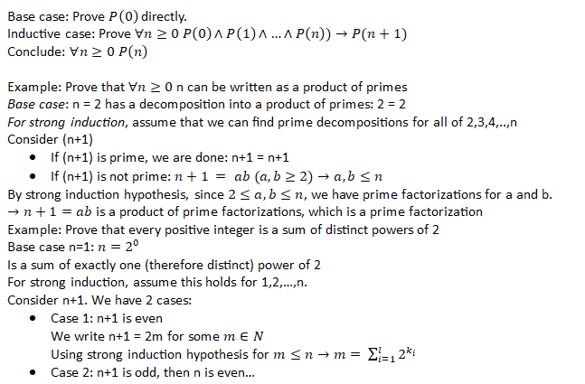

### Big-O Notation

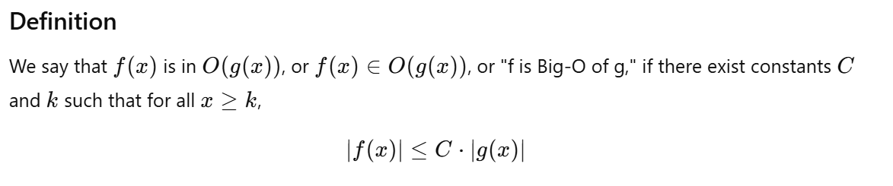

## 12 - Running times, Complexity Theory, and Models of Computations

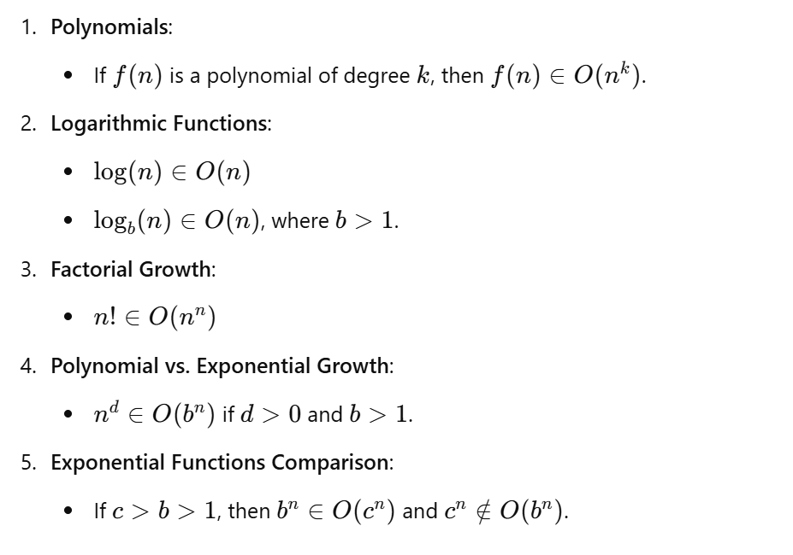

### Phrase-Structure Grammar

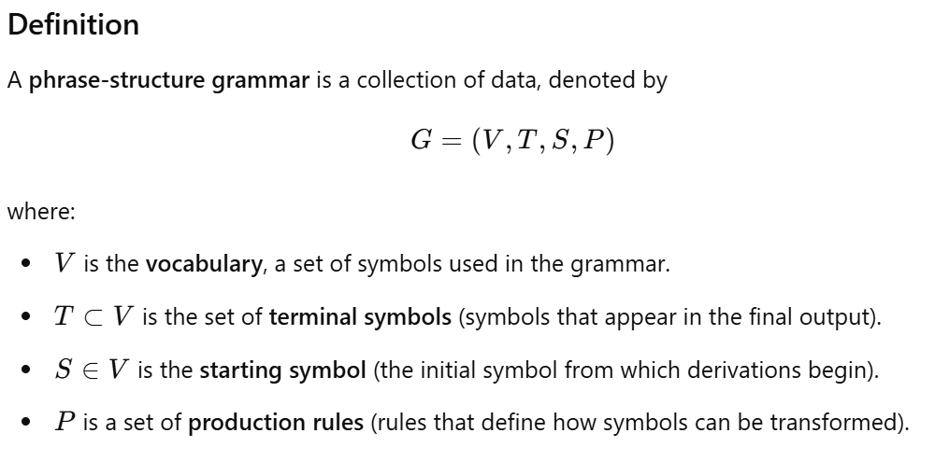

### Finite-State Machine

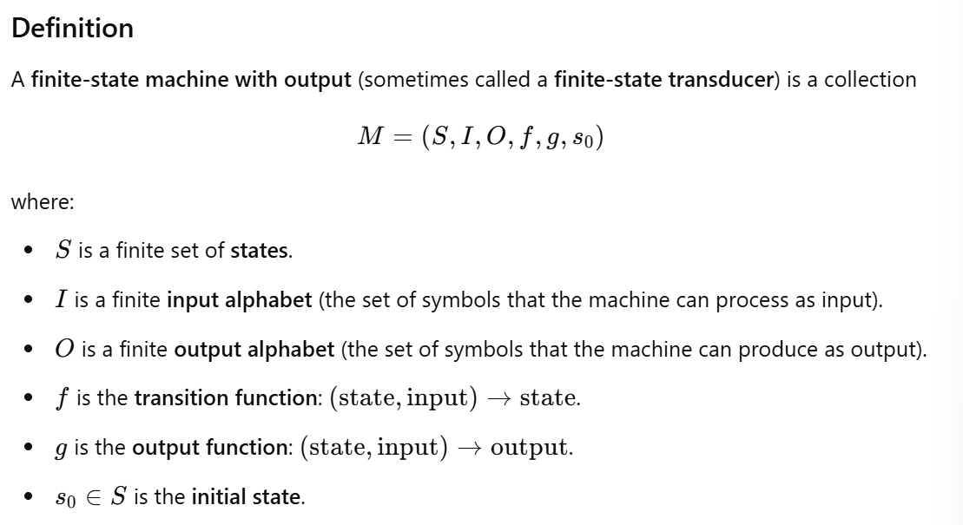

### State Diagrams

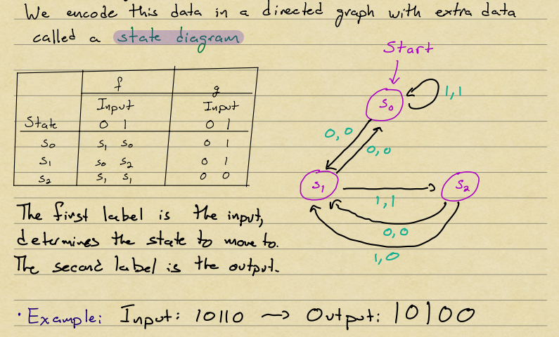

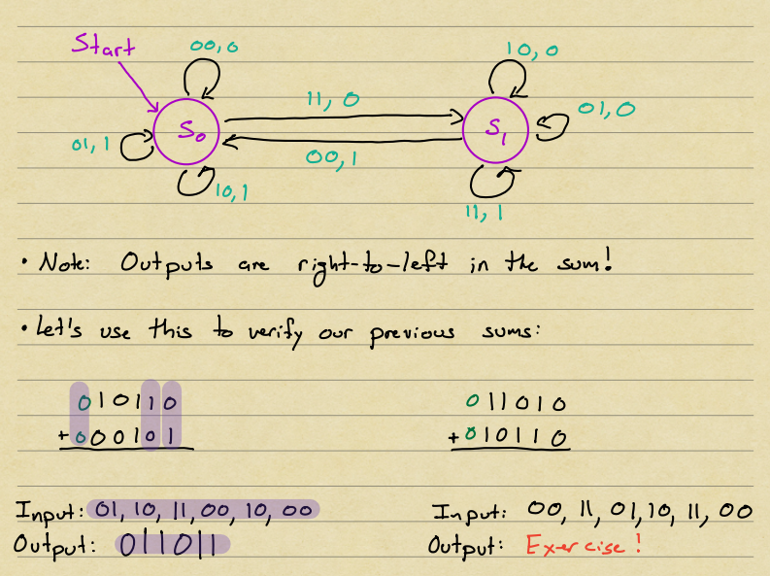

## 13 - Finite State Automata and Regular Languages

### Finite-state Automaton

